**MODULE – 1**

**SE - Overview of IT Industry**

* What is software ? What is software engineering ?

**Software** is a set of instructions, data or programs used to operate computers and execute specific tasks.

**Software engineering** is defined as a process of analyzing user requirements and then designing, building and testing software application which will satisfy those requirements.

* Explain Type of software

There are many type of software

1. Application Software

* + - * This is a most common type of software.
      * Application Software is a computer software package that Performs a specific function for a user, or in some cases, for Another application.
      * An application can be self-contained, or it can be a group of programs that run the application for the user.

2. System Software

* These software programs are designed to run a computer's application programs and hardware.
* System software coordinates the activities and functions of the hardware and software.
* It controls the operations of the computer hardware and provides an environment or platform for all the other types of software to work in.

3. Driver Software

* Also known as device drivers, this software is often considered a type of system software.
* Device drivers control the devices and peripherals connected to a computer, enabling them to perform their specific tasks.
* Every device that is connected to a computer needs at least one device driver to function.

4. Middleware

* The term middleware describes software that mediates between application and system software or between two different kinds of application software. For example, middleware enables Microsoft Windows to talk to Excel and Word.
* It is also used to send a remote work request from an application in a computer that has one kind of OS, to an application in a computer with a different OS. It also enables newer applications to work with legacy ones.

5. Programming Software

* Computer programmers use programming software to write code. Programming software and programming tools enable developers to develop, write, test and debug other software programs.
* Examples of programming software include assemblers, compilers, debuggers and interpreters.
* What is SDLC? Explain each phase of SDLC

Full form of SDLC is Software Development Life Cycle.

SDLC refers to a methodology with clearly defined processes for creating high-quality software.

SDLC methodology focuses on the following phases of software development .

1. Requirement Gathering

* This is the first and fundamental stage of SDLC. Business analysts gather requirements from their customers, target market and industry experts to create a document.

2. Analysis

* This phase formally defines the detailed functional user requirements using high level requirements identified in the initiation and feasibility phases.

3. Designing

* This stage focuses on designing the product.it involves architects product and developers who will ideate and present a design of the project.

4. Implementation

* In this stage build a software using programming language.

5. Testing

* In this stage development team tests the software for errors and deficiencies. Does the software produce the right result?

6. Maintenance

* Because a software product usage varies from customer to customer, there may be unique issues that come up and need to be addressed. Theses customer issues are solved in this maintenance stage.

* What is DFD? Create a DFD diagram on Flipkart.

Full name of DFD is Data Flow Diagram.

The flow of data of a system or a process is represented by DFD.

It also gives insight into the inputs and outputs of each entity and the process itself.

DFD dose not have control flow and no loops or decision rules are present.

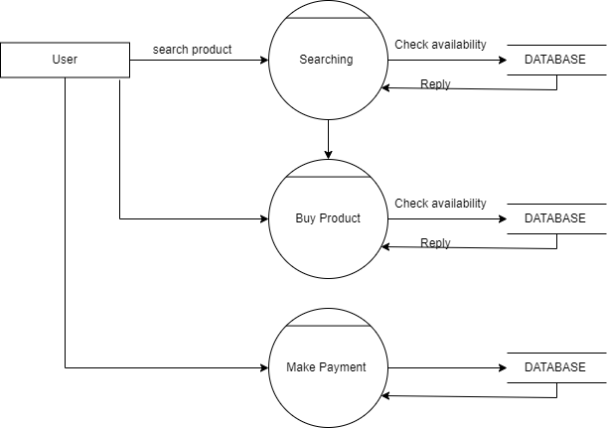

* What is Flow chart? Create a flowchart to make addition of two numbers.

A flowchart is a type of diagram that represents a workflow or process.

A flowchart can also be defined as a diagrammatic representation of an algorithm.

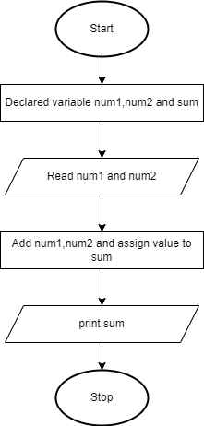

-

-

* What is Use case Diagram? Create a use-case on bill payment on paytm.

A use case diagram is used to represent the dynamic behavior of a system.

It encapsulates the system's functionality by incorporating use cases, actors, and their relationships.

It models the tasks, services, and functions required by a system/subsystem of an application.

It depicts the high-level functionality of a system and also tells how the user handles a system.

